
SHIRE HIGHLANDS EDUCATION DIVISION
2026 MALAWI SCHOOL CERTIFICATE OF EDUCATION MOCK
EXAMINATION

MATHEMATICS
Subject Number: M131/II
Thursday, 19th March, Time Allowed: 2 h 30 min
8:00 - 10:30 am

PAPER II
(100 Marks)

INSTRUCTIONS
- This paper contains 14 printed pages.
Please check.
- Answer all the six questions in section
A and any four in section B.
- The maximum number of marks for each
answer is indicated against each question.
- Scientific calculators may be used.
- All working must be clearly shown
- Write your Name at the top of each page
of your question paper in the spaces
provided.
- In the table provided on this page, tick
against the question number you have answered.
- At the end of the examination, hand in your paper to the invigilator.
Section A (60 marks)
Answer all the six questions in this section

- a) Without using a calculator or four figure tables, simplify the following surd, leaving the answer with a rational denominator (6 marks)
$\frac{4\sqrt{10a}}{3\sqrt{6a}-\sqrt{3a}}$

b) The sum of the first n terms of an arithmetic progression (AP) is given as
$S_{n}=n^{2}-3n$. Find the common difference. (6 marks)

- a) Figure 1 a kitchen serving dish made of a cylinder and a hemisphere having a
diameter of diameter 50cm.
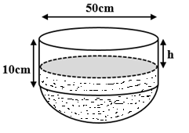
Figure 1

If ${500cm}^{3}$ of water were poured into the dish, calculate the height,h, leaving the answer correct to two decimal places (7 marks)

b) Given that ${Log}_{3}6=1.631$, evaluate ${Log}_{3}0.5$ (5 marks)

- a) Figure 2 shows triangle PQR in which PQ = 6cm, angle PQR = $60°$. If its area is ${2m}^{2}$, calculate the length of QR. (4 marks)
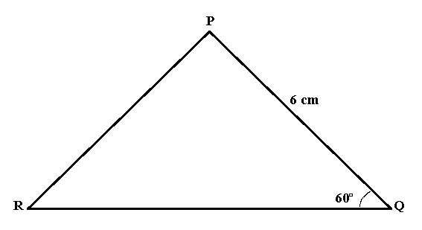
Figure 2

b) Simplify the given fraction to the lowest term. (4 marks)
$$\frac{{2t}^{2}-14t}{t^{2}-49}$$

- a) In a class of boys and girls, there are 50 learners, 35 of which are girls. If the class has 27 of which are prefects. If a learner is picked at random, find the probability that the learner is either a boy or a prefect, leaving your answer in lowest form. (6 marks)

b) Figure 2 shows polygon KLMN in which $KN=\underline{a}, KL=\underline{b}$. P is a point on NM such that $NP=KL and NP=2PM$. Express LM in terms of $\underline{a}$and$\underline{b}$. (6 marks)
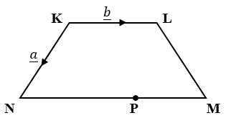
Figure 2

- a) Table 1 shows a data set representing the number of chambo caught in a certain lake recorded on daily basis.
Table 1
Class interval | Number of days | Mid point
20 – 30 | 4 | 25
31 – 41 | 10 | 36
42 – 52 | 8
53 – 63 | 16 | 58
64 – 74 | 12 | 69
- Complete table 1 by filling in the missing value (1 mark)
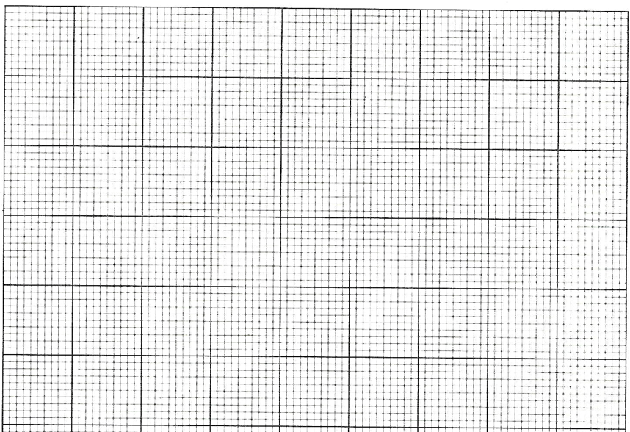
- Use the data to draw a frequency polygon in the graph provided below. (5 marks)

b) $y={-x}^{2}+3x+4$ is the equation of a curve. Find the coordinates of its
turning point. (5 marks)

- In the same figure, construct:
- a circle centre O with diameter 7cm.
- a point N which is 5cm away from O.
- a tangent NT at a point T on the circumference.
- Measure and state the length of NT (7 marks)

Section B (40 marks)
Answer any four questions from this section.

- Solve the equation ${ x}^{3}+3x^{2}-4x=12$. (10 marks)

- Tamanda, Chisomo and Wongani are playing jingo using a string. Tamanda is standing 2m North of Chisomo while Wongani is standing 4m away from Chisomo on a bearing of $300°$.
  - How far is Wongani from Tamanda? (6 marks)

  - Calculate the bearing of Wongani from Tamanda. (4 marks)

- The price of mango juice is partly constant and partly varies with the square of the number of mangoes used. The juice made using 8 mangoes costs K7,000.00 while the juice made using 9 mangoes costs K8,700.00. Find the cost of juice made using 11 mangoes. (10 marks)

- Table 2 shows x values for the equation $y={2x}^{2}-3x+1$

Table 2
x | -2 | -1 | 0 | 1 | 2 | 3 | 4
y | 15 |  | 1 | 0 | 3 |  | 21

- Complete the table by filling in the missing values. (2 marks)

- Use the table to plot the graph of the equation$y={2x}^{2}-3x+1$. Use the scale of 2cm to represent 1 unit in the horizontal axis and 2cm to represent 4 units in the vertical axis. (5 marks)

- Using the graph you have drawn in 10 a) above, solve the equation
${2x}^{2}-3x+1=2-2x$ (3 marks)

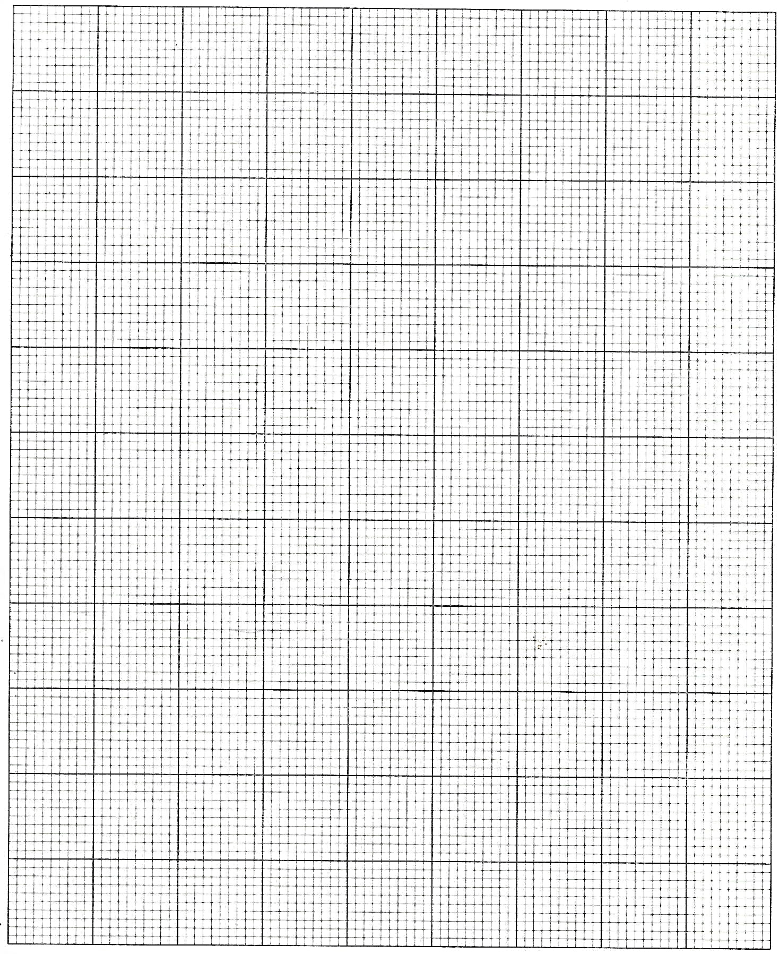

- The probability that Grace passes Physics is $3/4$, the probability that she passes Chemistry $2/3$ while the probability that she passes Mathematics is $1/4$. In order to be selected to a nursing school, one has to pass any two of these subjects. Draw a tree diagram and use it to find the probability that Grace will be selected to the nursing school. (10 marks)

- A mother is twice as old as her daughter. In 5 years, the product of their ages will be 1125. Find the present ages of the mother and daughter. (10 marks)

END OF QUESTIONS

NB: This paper has 14 pages.

